[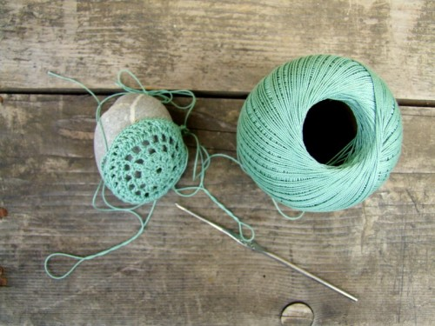](http://www.kirschkernzeit.ch/wordpress/?attachment_id=5849)

[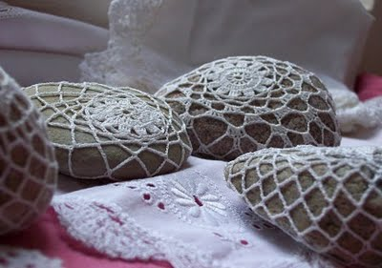](http://4.bp.blogspot.com/_chJsERqwF1I/SyYNIxrwseI/AAAAAAAABV8/EXQgqnyemhY/s1600-h/steine_seitlich.JPG)

[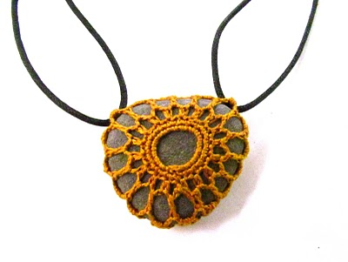](http://schoenstricken.de/2013/01/5076/img_3391/)